School Holiday Vaulting Lessons Dec/Jan 2016

Lessons are $45 per person. Bookings are essential as numbers are limited.

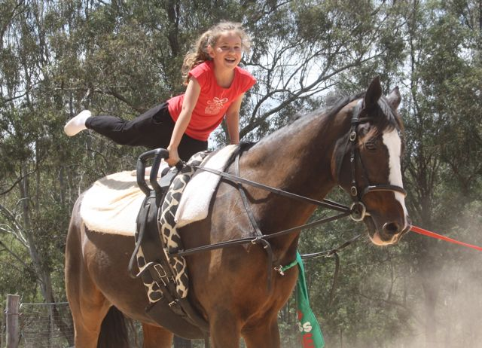
Dates:
Saturdays 9.30am-11am 19th Dec, 2nd Jan, 9th Jan
Mondays 5.30pm-7pm 21st Dec, 4th Jan, 11th Jan
Wednesdays 9.30am-11am 30th Dec, 6th Jan, 13th Jan

No previous experience necessary. Bring water, hat and sun block and wear stretchy pants & soft-soled shoes.

Phone Lyn: 0412 240 397 or email lynlynch@bigpond.net.au
…………………………………………………………………………………….…………………………………………………
Booking Form – Please complete and return with your payment to secure your place.

Name___________________________________________________Age__________________________

Address_______________________________________________________________________________

Phone_________________________________ Email__________________________________________

Days attending_________________________________Amount enclosed__________________________

Return to: Lyn Lynch 88 Scheyville Rd Oakville 2765

Payment options: EFT (please email a copy of the EFT receipt) or by Credit Card

The bank details are
Cobb & Co Equestrian Pty Ltd: ANZ BSB: 012 874 Account Number: 2154 71299
Please send copy of remittance with booking.

